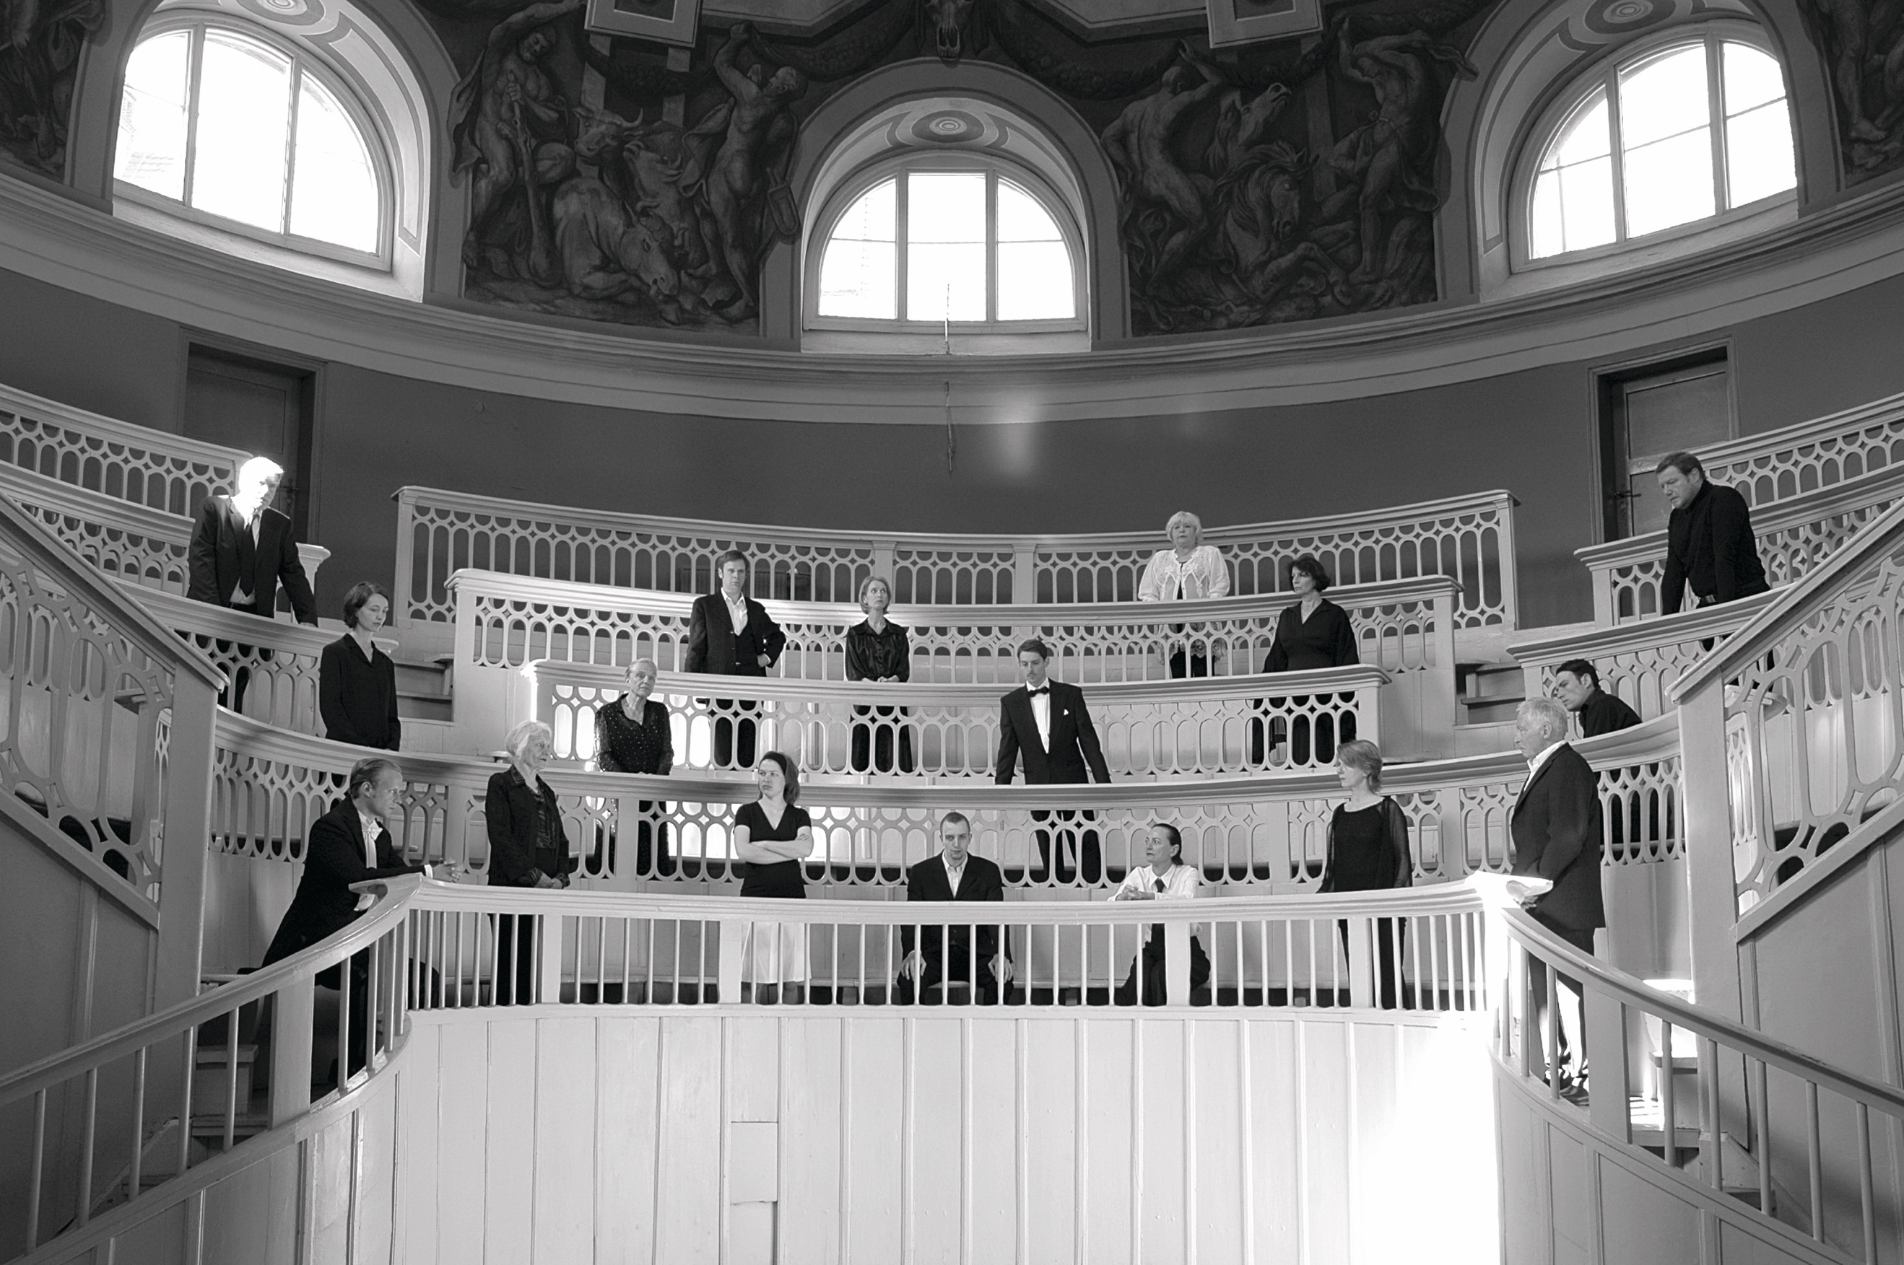
Ana Torfs, Anatomy, 2006, slide photograph, photo: Ana Torfs and courtesy of the artist

Press Preview: 9.3.2017
Official Opening: 10.3.2017
Public Programme: 11-12.3.2017
On view: 11.3-21.5.2017
Press Contact: Katelijne Lindemans | katelijne@contourmechelen.be

Contents

Contour 3
Contour Biennale 8 3
Artists and Collectives 4
Biennale Venues 5
About Natasha Ginwala 9
Press Images 10
Contour Biennale 8 in the press 10
Practical Information 11
Partners & Support 13
Contact 15

Contour
The Contour Biennale is one of the most well recognized large scale exhibition platforms in Belgium — a unique initiative engaging with local and international artists focusing on the moving image and its expanded representation through installation, sound and performance. Since 2003, Contour takes place in the historic city of Mechelen, which has been an important cultural and political centre in Flanders. This biennale maintains a growing connection with the city architecture and built environment that spans from the Medieval to the post- war Modern period. For each edition an international curator is nominated to conceive a fresh framework and visual identity.

Contour has become a crucial event on the calendar of European art events and festivals, since it unveils a wide range of commissioned and recent art projects that address some of the most relevant matters of the present from an aesthetic, social and political vantage point. With an extending global network, the organization continues to carry out additional projects between biennale editions to promote experimental strategies in contemporary art and its association with new publics.

Contour Biennale 8
Contour Biennale 8 Polyphonic Worlds: Justice as Medium evolves in drawing relations between contemporary artistic practice and the course of social justice against the 400-year old juridical past of Mechelen’s Great Council—Europe’s first courthouse. From the vestiges of this judicial infrastructure, what might it mean to survey the field of social justice and its implements as media archaeology such that justice itself is considered a "medium" that is simultaneously a performative, ethical and aesthetic operation.
With the limits of justice now unravelling in a volatile crisis of ethics in the global present, Contour Biennale 8 engages a polyphonic view that recalls the acoustic history of the Lowlands while presenting a notational landscape that is multiphonic, carrying overtones that are heard as a plural consciousness, and at times as states of discord. This biennial sets out to question the preconceived boundaries between the perception of legality and illegality within today’s experience of statehood.
The eighth biennale edition includes several newly commissioned film-based works and artistic projects by 25 artists and collectives.

Artists and Collectives
Adelita Husni-Bey (*1985 in Milan (Italy), lives in New York)
Agency/Agentschap/Agence (*1992, based in Brussels (Belgium))
Ana Torfs (*1963 in Mortsel (Belgium), lives in Brussels)
Arvo Leo (*1981 in Aotearoa, lives in Amsterdam)
Basir Mahmood (*1985 in Lahore (Pakistan), lives in Lahore and Amsterdam)
Beatriz Santiago Muñoz (*1972 in San Juan (Puerto Rico), lives in San Juan)
Cooking Sections
Council (Grégory Castera & Sandra Terdjman) (*2013, based in Paris (France))
Eric Baudelaire (*1973 in Salt Lake City (Utah, United States), lives in Paris)
Filipa César (*1975 in Porto (Portugal), lives in Berlin) and Louis Henderson (*1983 in Norwich (United Kingdom), lives in Paris and Lisbon)
Ho Tzu Nyen (*1976 in Singapore, lives in Singapore)
inhabitants (Mariana Silva & Pedro Neves Marques) (*2015, based in New York (United States))
Judy Radul (*1962 in Lillooet (Canada), lives in Vancouver and Berlin)
Karrabing Film Collective (*2010 based in the Northern Territory (Australia))
Lawrence Abu Hamdan (*1985 in Amman (Jordan), lives in Beirut)
Madonna Staunton (*1938 in Murwillumbah (Australia), lives in Brisbane)
Otobong Nkanga (*1974 in Kano (Nigeria), lives in Antwerp)
Pallavi Paul (*1986 in New Delhi (India), lives in New Delhi)
Pedro Gómez-Egaña (*1976 in Bucaramanga (Colombia), lives in Bergen and Copenhagen)
Rana Hamadeh (*1983 in Beirut (Lebanon), lives in Rotterdam)
Ritu Sarin and Tenzing Sonam (*1959 in New Delhi (India) and *1959 in Darjeeling (India), live in Dharamshala)
Rossella Biscotti (*1978 in Molfetta (Italy), lives in Brussels)
Susanne M. Winterling (*1970 in Rehau (Germany), lives in Berlin)
Trevor Paglen (*1974 in Maryland (United States), lives in Berlin)
Trinh Thi Nguyen (*1973 in Hanoi (Vietnam), lives in Hanoi)

Curator
Natasha Ginwala
Advisers
Judy Radul
Denise Ferreira da Silva
Assistant Curator
Krisztina Hunya

Exhibition Architecture
Richard Venlet (with Maxime Prananto and Carlo Siegfried)
Graphic Design
Studio Remco van Bladel

Biennale Venues
Contour Biennale 8 is located across several historical sites and at contemporary art venues in Mechelen city. These sites traverse the grounds of legal history, civic rituals, the passage of medieval governance and advance of polyphonic music in the Low Countries. Artistic projects engage with each venue to explore its varied pasts while corresponding with our global present.

- The Garage
The Garage, a contemporary arts center prominently located in the vicinity of the St. Rumbold’s Cathedral is a key venue for Contour Biennale 8. Repurposed as a white cube, the site still bears evidence of its former lives as a guesthouse of the nobility, a butcher’s shop, a brasserie, and a city parking lot. The Garage hosts an annual program of contemporary art exhibitions and has traditionally been a key site for previous Contour Biennale editions as part of Cultuurcentrum Mechelen.

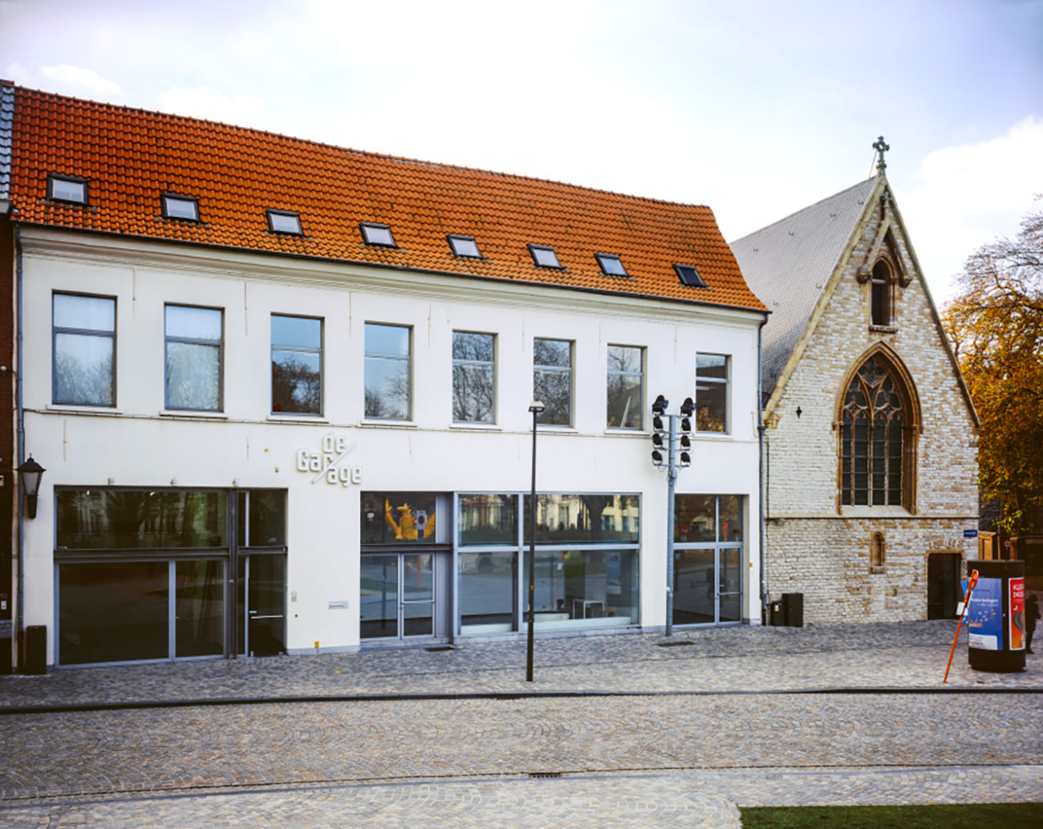

- Alderman’s House
Alderman’s House (Schepenhuis), at the city’s main square, built in the thirteenth century, is most likely the oldest surviving stone-laid city hall in Belgium. With Gothic elements being added to this iconic structure in the fourteenth century and with the expanding geopolitical significance of Mechelen, the Schepenhuis remained a central agent in the daily operation of regional governance as well as a space for exercising justice after the establishment of the Great Council in the fifteenth century. Until the Great Council’s relocation to the Court of Savoy in 1616, this building was symbolic for the popular expression used during legal disputes: “Let us go to Mechelen!” that denoted a visit to this influential judicial seat in the Low Countries as a last resort. Two wall paintings in the main courtroom where the Great Council assembled reveal the Crucifixion of Christ and on the opposite wall the Last Judgment which holds within it a mirror that reflects the council in session—dated 1526. As divine allegories and exemplia iusticiae, it was believed that these paintings guided the judges to reach just verdicts. Various rooms within the three-storey building have been previously used as a prison, a fencing school, an art academy, and a city archive. For the first time, this Contour Biennale edition is hosted in the entire building premises.
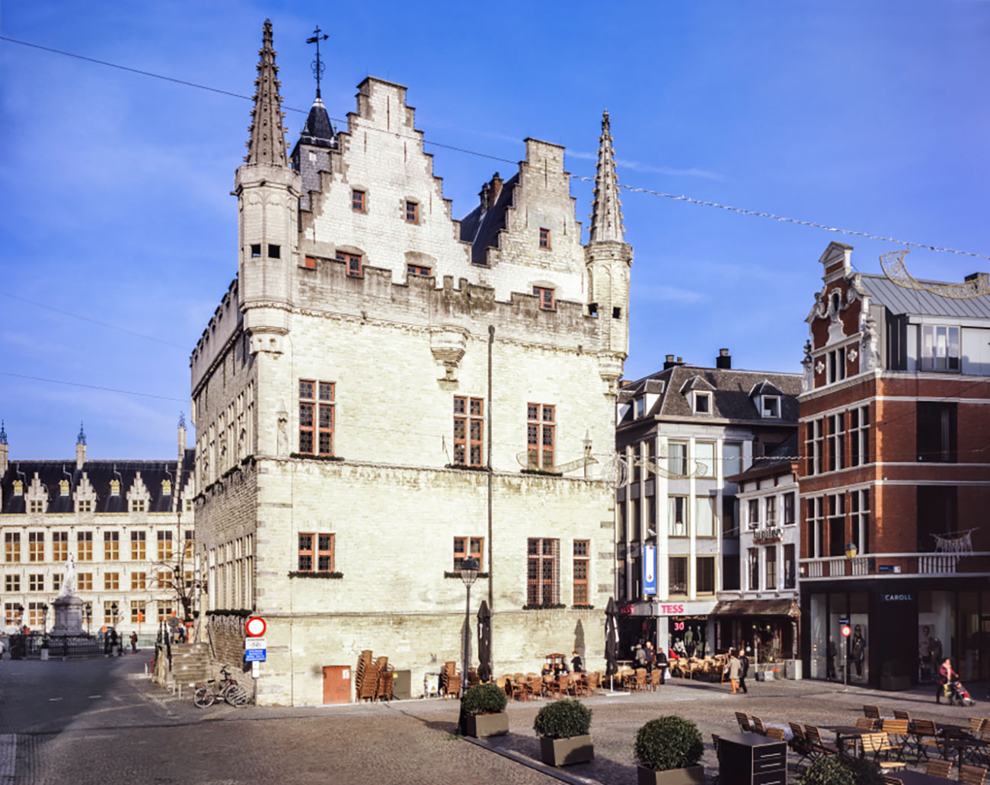
- Court of Savoy
Court of Savoy (Hof van Savoye), the sixteenth-century Renaissance site, was rebuilt as the Palace of Margaret of Austria, Regent of the Habsburg Netherlands, and currently houses the lower courts for criminal and civil proceedings. The building’s façade is decorated with a sculpture of Justitia that pushes notions of imparting balanced judgment and the representation of truth to the foreground. As Margaret of Austria was a great patron of the arts and music, influential figures of the Renaissance period, painters Bernard van Orley, Jan Gossaert, and Albrecht Dürer, as well as humanists such as Erasmus, visited the former palace. Franco-Flemish polyphonic music flourished in the Habsburg-Burgundian Court with musical offerings led by composers Pierre de la Rue, Josquin des Prez, Johannes Ockeghem, and Jacob Obrecht. The texture of polyphonic music is based on an equivalence of different voices singing or playing simultaneously, capturing an intrinsic collectivity in which each vocal part becomes uniquely interrelated with the whole. Margaret of Austria’s favorite scribe, a music calligrapher, instrumentalist, and mining engineer, who went by the pseudonym Petrus Alamire (referring to the musical notes a-la-mi-re), produced several lavishly decorated illuminated manuscripts, which played a strategic diplomatic role in the course of establishing the sovereign’s image amid the networks of European governance. Alamire is a mysterious personality who is also alleged to have been a spy—let us call him an historical double agent. Contour Biennale 8 artists will make use of the civil court’s waiting room (the former throne room), and the baroque garden.
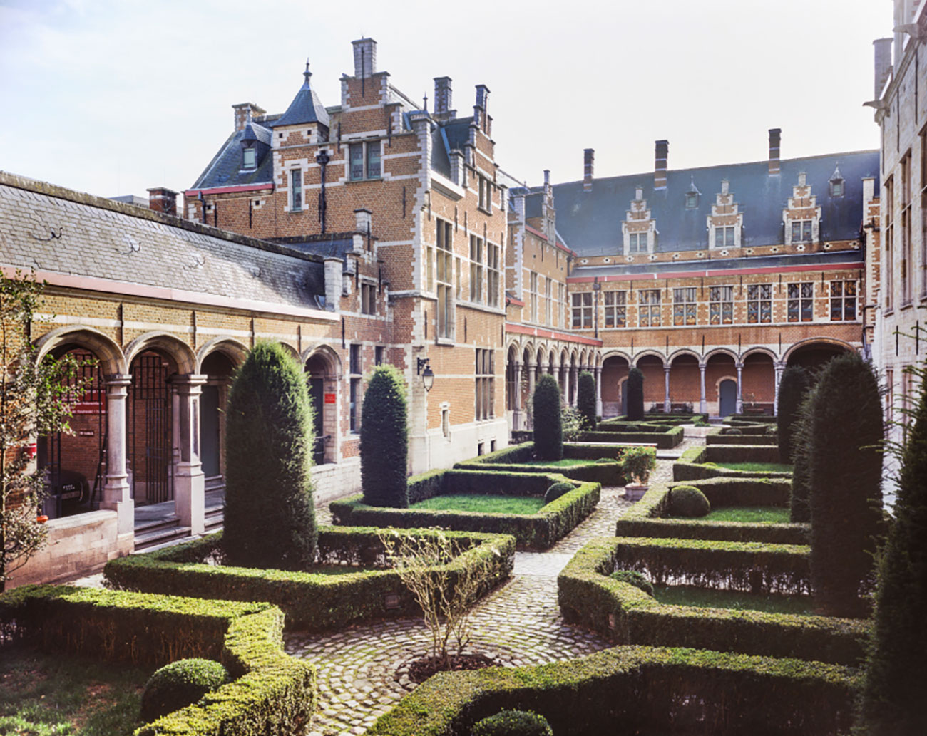

- House De Clippel
House De Clippel. Locally referred to as “The Empress,” the House De Clippel is a fifteenth-century manor that played host to various figures of the Dutch nobility as a private residence, and later as a hotel and a wine merchant. This building came into the ownership of the Michiels family in 1890, who have been Mechelen city’s watchmakers for generations. The family’s reputation goes back to the year 1860, when Edward Michiels invented a way to operate tower clocks electronically. Luc Michiels, his grandson, continues to maintain his workshop, which extends into a lush backyard garden where aged clock motors, minute pointers, tower bells, and gigantic clock dials await repair and future implementation. During Contour Biennale 8, the wine cellar in the house will be transformed into an oceanic zone where bioluminescent agents partake in environmental justice.
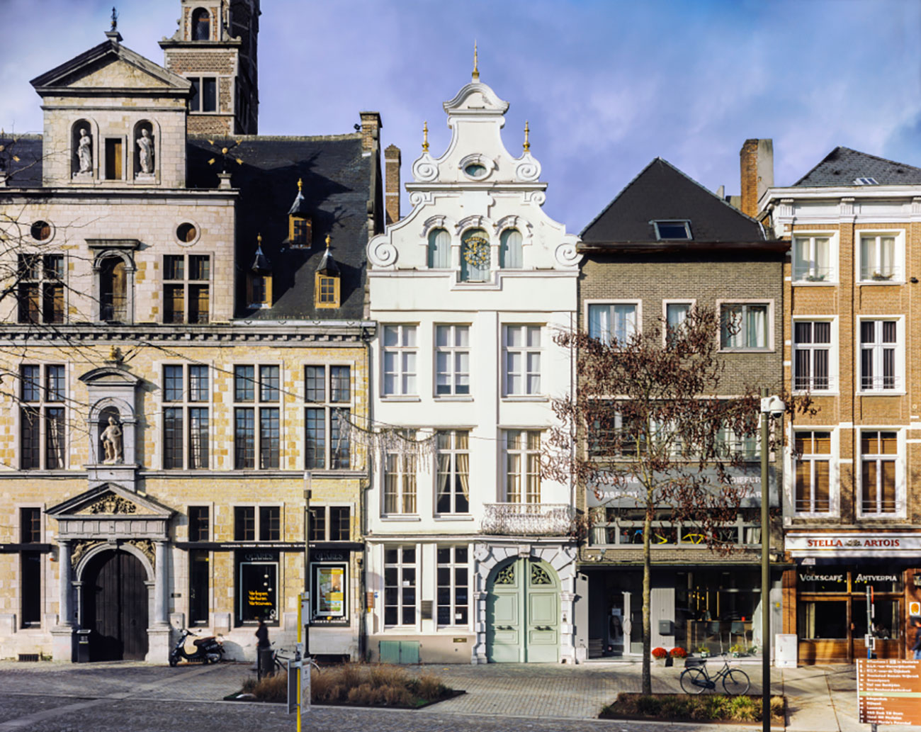

- The House of the Great Salmon
The House of the Great Salmon, located next to the wharf, is one of the finest examples of early Renaissance architecture in the Low Countries. Often referred to as the Dijlestad (“city located at the river Dyle”), Mechelen maintained an important connection with waterways in terms of trade as well as mercantile transport. Building upon this legacy, Contour Biennale 8 examines links to the neoliberal settler state, water bodies, and extractive commerce. Originally owned by a monastery for lepers and later bought by the fish merchants’ guild, the entrance door features an engraved golden salmon alluding to the commercial wealth and global networking prowess of Flemish guilds.
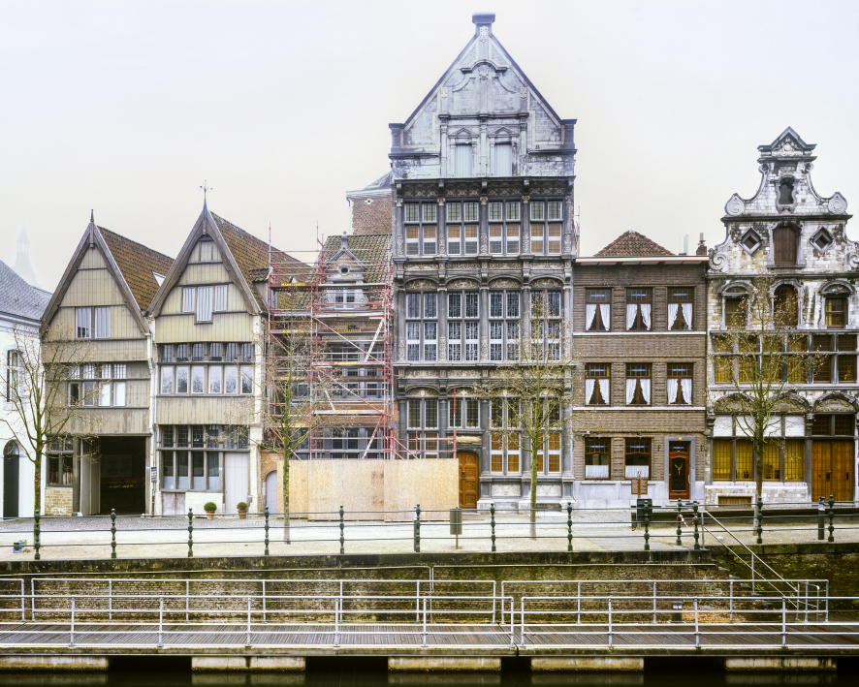

- Warehouse & Co-working Space
Moving from the city center, the closing venue of Contour Biennale 8 is an industrial warehouse and social working site at Battelsesteenweg 50, which was formerly a furniture factory and now hosts a collectively run space including a carpentry workshop, cycle shop, and experimental theater group. Since the late 1970s ROJM, a popular youth center, also shares the premises. In this venue, the biennial brings together commissioned works that reflect a common poetics around informal labor, postindustrial subaltern narratives, and self-governance; the lighthouse and the colonial frontier are set in resonance with the multiple functions of this layered site serving different demographic groups of Mechelen.
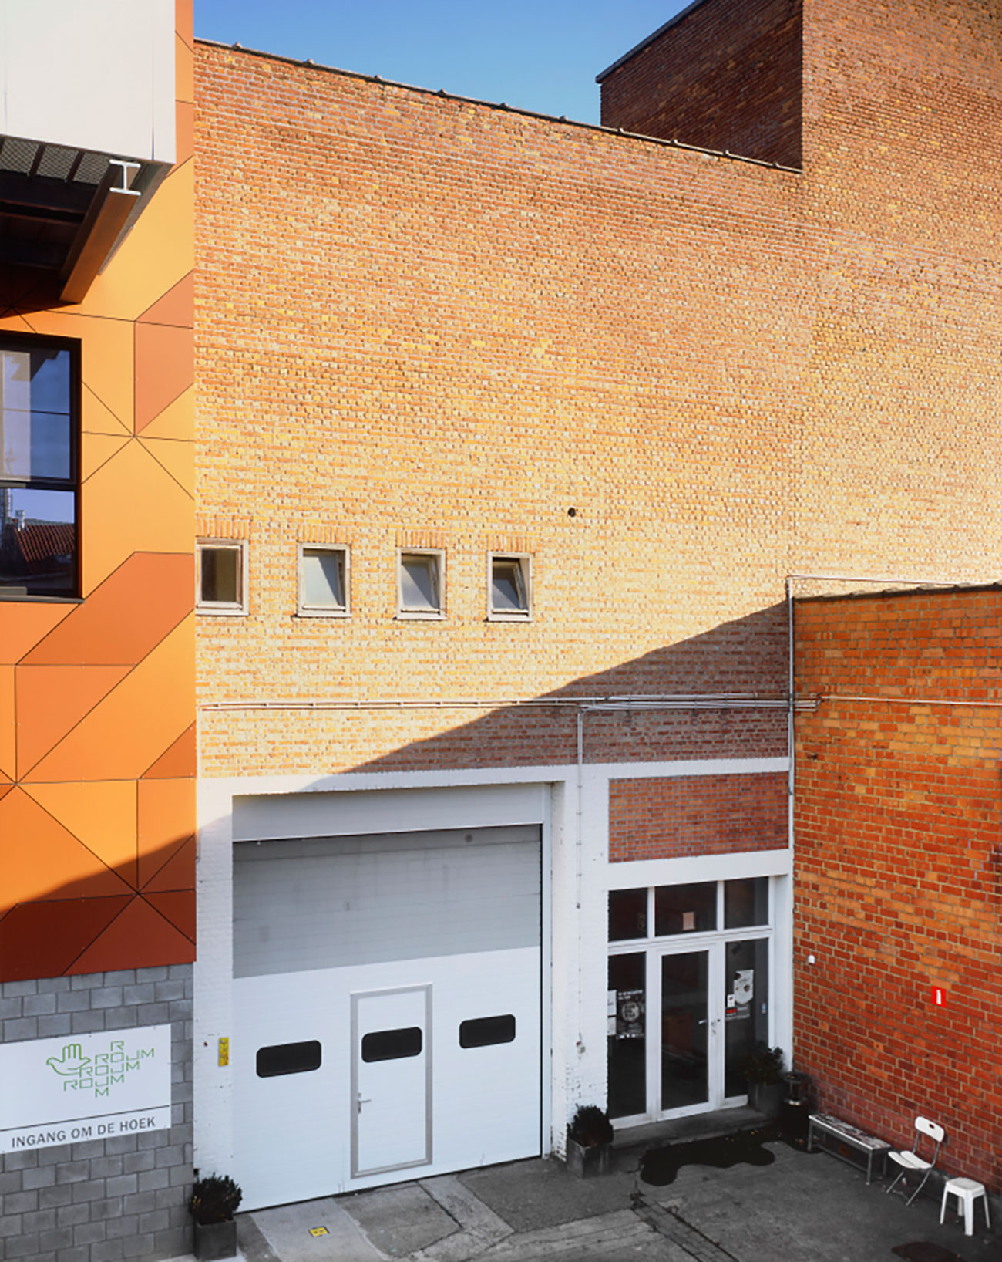

About Natasha Ginwala
Natasha Ginwala is a curator, researcher, and writer. She is curator of Contour Biennale 8 and curatorial advisor for documenta 14 (2017). Her recent curatorial projects include My East is Your West featuring Shilpa Gupta and Rashid Rana at the 56th Venice Biennale; Mind Moves Matter at L' appartement 22, Rabat; Still Against the Sky at KW Institute for Contemporary Art, Berlin, and Corruption: Everybody Knows... at e-flux, New York within the framework of the SUPERCOMMUNITY project. Natasha Ginwala was a member of the artistic team for the 8th Berlin Biennale for Contemporary Art (with Juan A. Gaitán) and curated The Museum of Rhythm at Taipei Biennial 2012 (with Anselm Franke) and Muzeum Sztuki in Lodz 2016 (with Daniel Muzyczuk). From 2013–15 she led the multi-part curatorial project Landings presented at the Witte de With Center for Contemporary Art, David Roberts Art Foundation, NGBK (as part of the Tagore, Pedagogy, and Contemporary Visual Cultures Network), the Stedelijk Museum Amsterdam, and other partner organizations (with Vivian Ziherl). Ginwala trained in Visual Studies at the School of Arts and Aesthetics, JNU in New Delhi and participated in the de Appel Curatorial Programme, Amsterdam. She has written on contemporary art and culture in journals such as The Exhibitionist, e-flux journal, Ibraaz, Afterall and has contributed to numerous publications.

Press Images
Susanne M. Winterling, Glistening troubles, 2017, CGI animation still, courtesy of the artist

Please find press images here: https://drive.google.com/open?id=0B5p-17GJes5pOTBWYjgxWk1GenM

More images on request: katelijne@contourmechelen.be

Contour Biennale 8 in the press
Tess Maunder, A Conversation with Natasha Ginwala. Published 15/02/2017 on Ocula. Interview accessible via https://ocula.com/magazine/conversations/natasha-ginwala/

Ive Stevenheydens, Wat is rechtvaardigheid in een samenleving als de onze? Published in Metropolis M, 1/2017.

Hoe recht is de rechtspraak, Published in H ART #167 (12.02.2017)

Here Are the Artists and Collectives Participating in Belgium’s Contour Biennale 8. Published on Artnet (4.11.2016) Online accessible via https://news.artnet.com/art-world/participants-in-belgiums-contour-biennale-8-732938

Pieter Van Bogaert, De vliegende curator. Published in H ART #160 (15.09.2016), 6-7.

Natasha Ginwala, Curator of Contour Biennale 8 and Curatorial Advisor for documenta 14. Interview for Radicate.eu published 10.6.2016. Online accessible via http://www.radicate.eu/natasha-ginwala-curator-for-contour8-and-curatorial-advisor-for-documenta14/

For Contour Biennale 8 newsletters and press releases, please contact: Katelijne@contourmechelen.be

Practical Information

On view
Contour Biennale 8 Polyphonic Worlds: Justice as Medium is on view from 11 March until 21 May 2017. The exhibition is open from 9 to 17 h during weekdays, and between 10 and 18 h in weekends. The Biennale is closed on Wednesdays.

Tickets
€ 10: standard price
€ 8: Mechelen residents / - 25 / +65 / unemployed / people with disabilities / groups of 10 or more people
€ 2: teacher card / pupil and student card up to the age of 26
Free: - 12

Ticket Sale
City Festival OP.RECHT.MECHELEN.
Minderbroedersgang 5
2800 Mechelen

Tourism Mechelen
Hallestraat 2-4-6
+ 0032 (0)70 22 28 00
uit@mechelen.be
www.uitinmechelen.be

Tours
Contour Biennale 8 organizes guided tours for students and group visitors from across Belgium and abroad. The tours are exclusively designed along specific routes of the exhibition to broaden public engagement with durational artistic works, the research process, historical venues and Mechelen’s cultural past.
– Duration guided tour
Two hours
– Language
DU / EN / FR
– Number
Up to 20 persons per guide
– Price
€ 60 (Entry tickets excluded. The reduced rate of € 8 per ticket applies to groups of 10 people or more)
Reservations via Tourism Mechelen
For more information and reservation inquiries, please contact contour@nona.be

Partners & Support
Contour Biennale 8 is organized by:

Contour Biennale 8 is coproduced by:

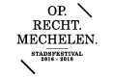

Supported by:

Cultural Partners:

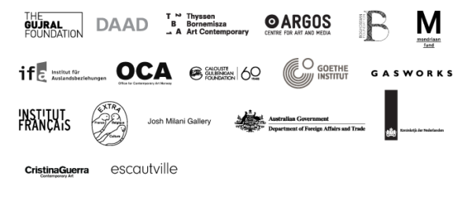
Logistic Partners

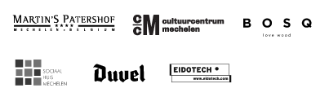

Educational partners:

Scientific partners:

Online Media Partner:

Partners of the City Festival OP.RECHT.MECHELEN:

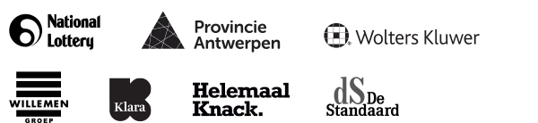

Contact
Steven Op de Beeck
Director
T. 0032 15 20 37 80
M. 0032 477 40 80 98
E. steven@contourmechelen.be
Alyssa Decq
Production & Education
T. 0032 15 20 37 80
M. 0032 474 51 57 85
E. alyssa@contourmechelen.be
Katelijne Lindemans
Communication & Press
T. 0032 15 20 37 80
M. 0032 479 48 32 46
E. katelijne@contourmechelen.be
NONA
Begijnenstraat 19-21
B-2800 Mechelen
www.contour8.be
www.nona.be
contour@nona.be

